**DAILY ONLINE ACTIVITIES SUMMARY**

|  |  |  |  |  |  |  |  |  |
| --- | --- | --- | --- | --- | --- | --- | --- | --- |
| **Date:** | 12-06-2020 | | | | | **Name:** | D Richard Franklin | |
| **Sem & Sec** | Fourth sem section A | | | | | **USN:** | 4AL18CS020 | |
| **Online Test Summary** | | | | | | | | |
| **Subject** | | Aadalitha Kannada | | | | | | |
| **Max. Marks** | | 25 | | **Score** | | | 19 | |
| **Certification Course Summary** | | | | | | | | |
| **Course** | 1. **Machine learning foundations** | | | | | | | |
| **Certificate Provider** | | | greatlearning | | **Duration** | | | 3 hr |
| **Coding Challenges** | | | | | | | | |
| **Problem Statement:**  1: Program to find the longest repeating sequence in a string  2: [Program to swap two numbers using friend as a bridge concept.](https://github.com/orgs/alvas-education-foundation/teams/2nd-year/discussions/106) | | | | | | | | |
| **Status:** completed | | | | | | | | |
| **Uploaded the report in Github** | | | | | yes | | | |
| **If yes Repository name** | | | | | <https://github.com/alvas-education-foundation/Richard_Franklin> | | | |
| **Uploaded the report in slack** | | | | | yes | | | |

**Online Test Details:**

It was from all the chapters and the test was for 25 minutes having 25 question all multiple choice question. The questions were simple and optimal and the score that I got was 19/25

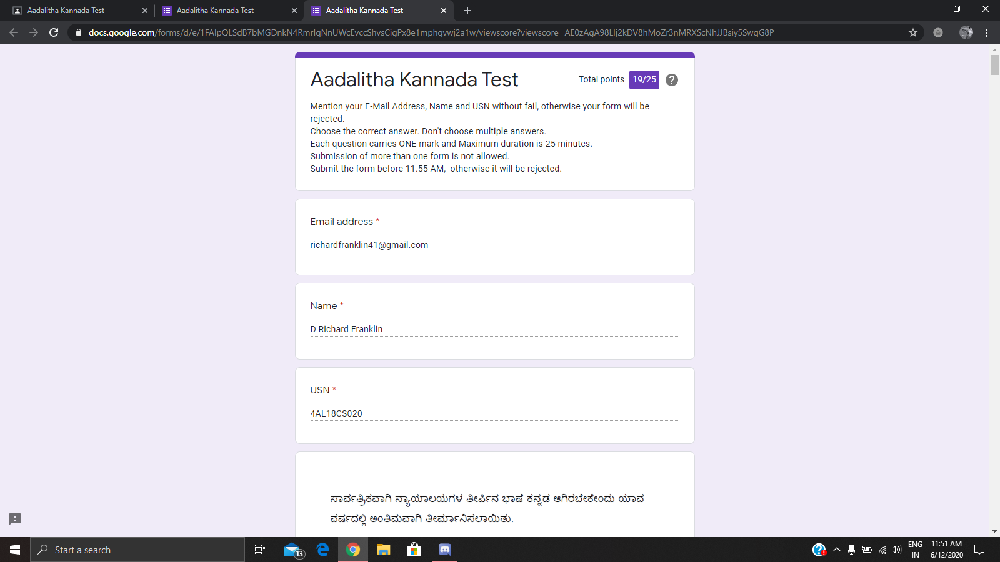

**Online Course Details:**

1. Name of course: **Machine learning foundations**

Certificate provider: greatlearning

The total course was about the basics and the necessary prerequisites for machine learning. I went through the remaining sections of the course which was about linear regression and logistic regression. I also had few tests to take as I was advancing through the course.

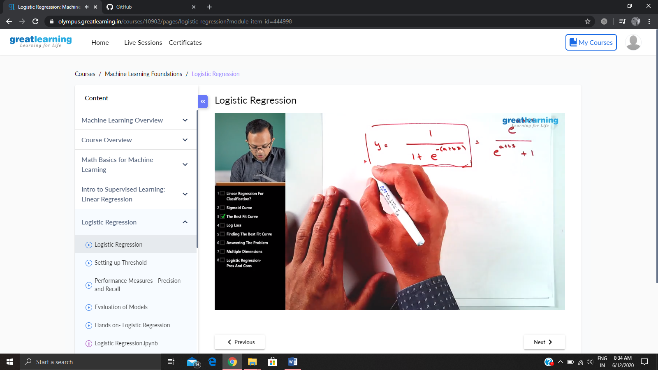

**Online coding:**

Problem 1: (using java) Program to find the longest repeating sequence in a string

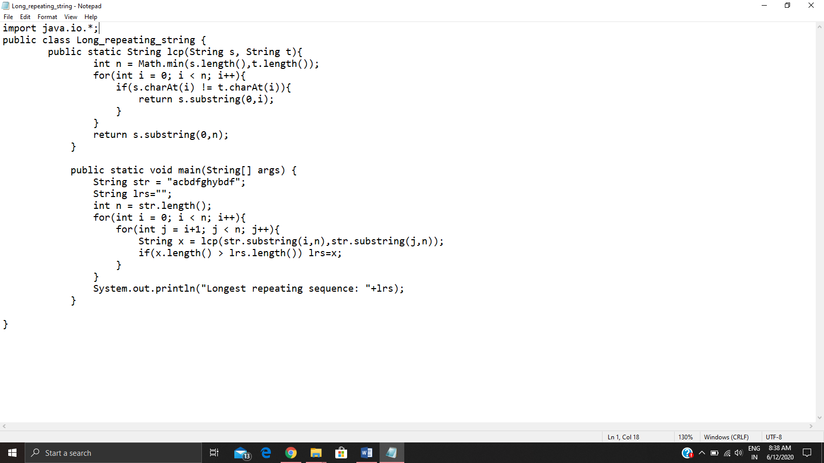

Problem 2: (using C++) [Program to swap two numbers using friend as a bridge concept.](https://github.com/orgs/alvas-education-foundation/teams/2nd-year/discussions/106)

